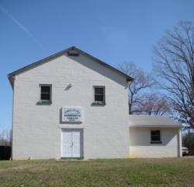
George James Community Center, Inc.
1215 George James Loop
Radiant, Virginia 22732
(540) 672-7138
General Membership Application
The George James Community Center, Inc., a non-profit 501© (3) organization, organized and Incorporated on April 12, 2006; will serve as an education instrument, social, as well as a recreational link, between Madison and the surrounding counties.
Please join us as a
“General Member”
George James Community Center, Inc.
Date: ________________
Name: __________________________________________________________________
Address: ________________________________________________________________
City: ____________________________ State:_______________ Zip:_____________
Email Address:__________________________________________________________
Telephone: Work: ______________ Home:________________ Cell:_____________
Annual General Membership Fee: $50.00 per person
Membership fee is "non-taxable" to the full extend provided by law.

Please make checks payable to: George James Community Center, Inc.
Mail to: George James Community Center, Inc.
General Delivery
Radiant, Virginia 22732
_________________________________________________
Signed By:

